**QUESTION 1:**

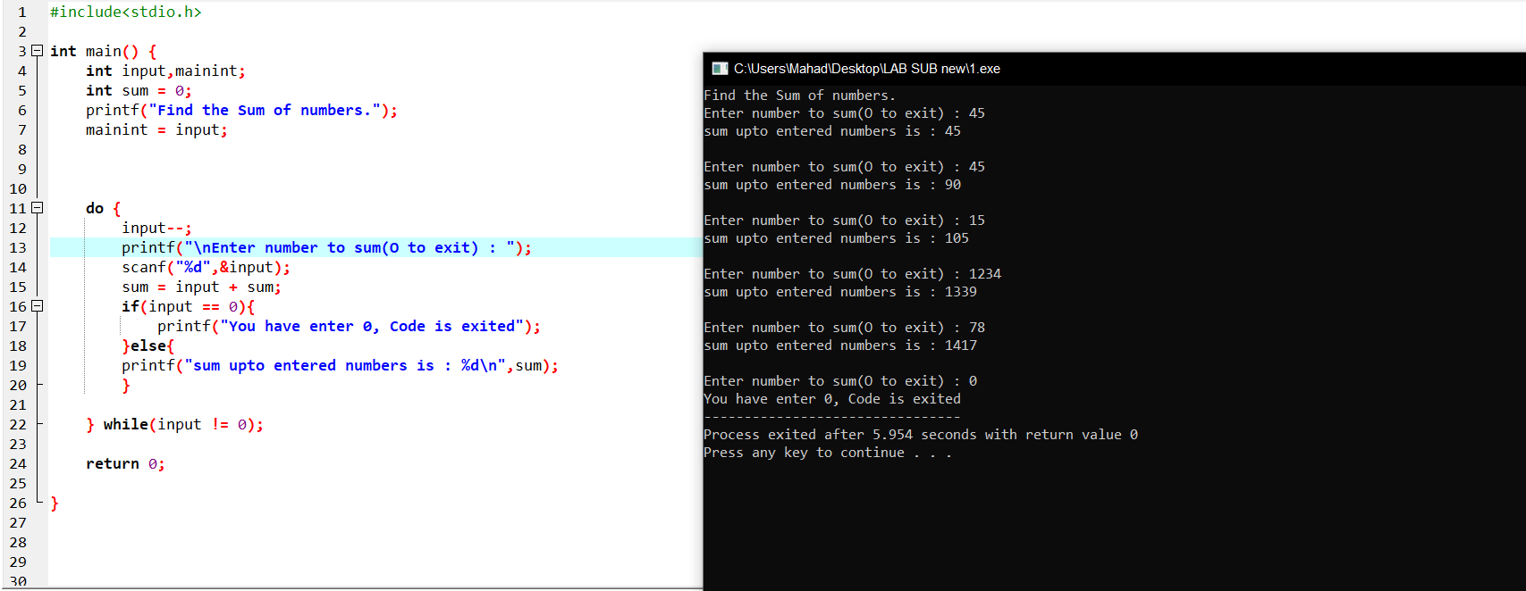

**QUESTION 2:**

**QUESTION 3:**

**QUESTION 4:**

**QUESTION 5:**

**QUESTION 6:**

**QUESTION 7:**

**QUESTION 8:**

**Long code(check in github 8.c file)**

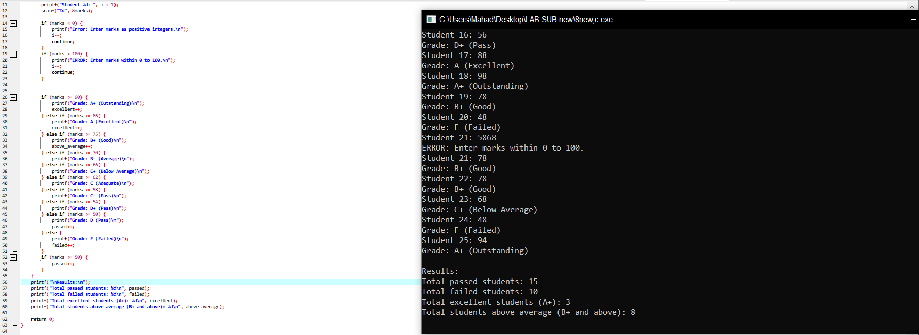

**QUESTION 9:**

